SCOPIC AUCTION APPLICATION

1. OVERVIEW

The application allow user to bid on an item displayed in the site.  
System admin can manage and set up item for auction.

1. SYSTEM ARCHITECTURE

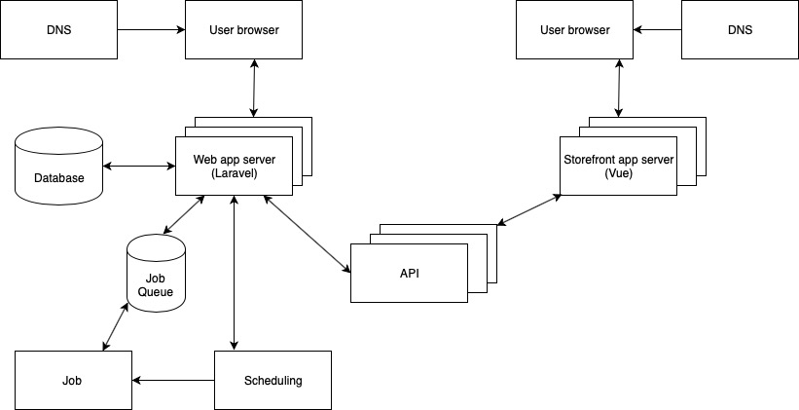

1. USE CASE DIAGRAM

Admin:

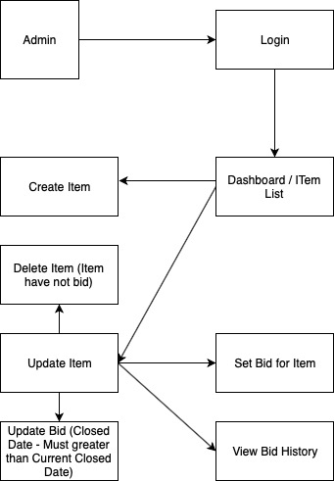

User:

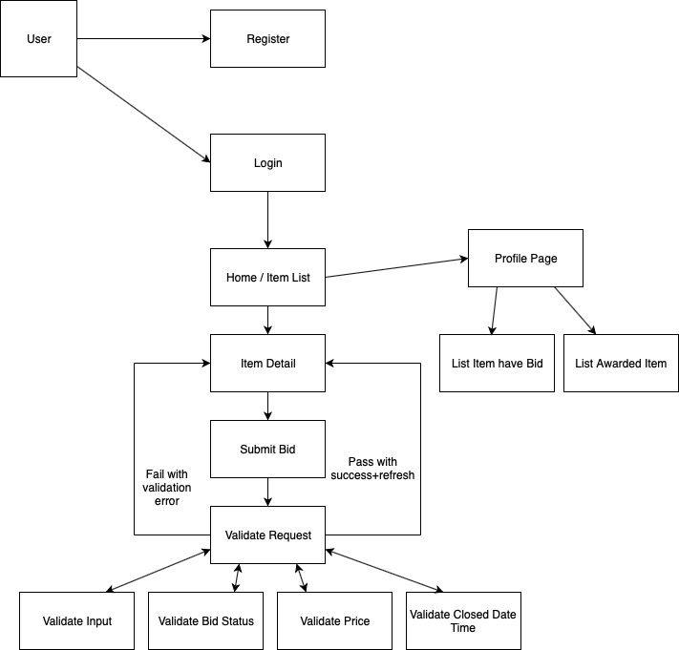

1. PROJECT SPECIFICATION
2. Backend

Framework: Laravel

Admin Dashboard: Laravel Blade Engine

Design Pattern Applied: Dependency Injection, Repository

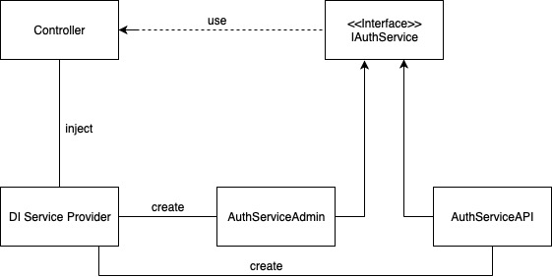

Scheduling: CompleteAuction  
 Check Deadline Auction  
 Mark as Completed  
 Dispatch Job to Send Email to Winner

Job Queue:  
 Send Email To Winner (dispatched from Scheduling)  
 Send Email To Other Auctioneer (when User set bid, an email will be sent to other user have bid in the Item)

API:

Authentication: JWT

List of API service for Storefront:  
 Post: /api/v1/login  
 Post: /api/v1/regiser  
 Post: /api/v1/bid  
 Get: /api/v1/items  
 Get: /api/v1/item?item_id=1  
 Get: /api/v1/items-bid  
 Get: /api/v1/items-awarded

1. Storefront

Framework: Vue 2.6

1. SOCKET IO (NOT YET IMPLEMENT)

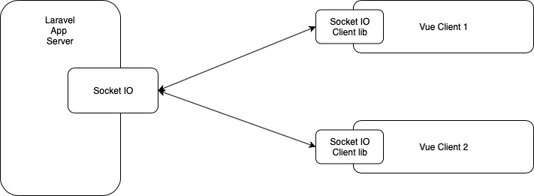

1. SCREENSHOTS